Name:____________________________________________________________ Period_________ Due Date:__________________
Family Meal Homework Assignment
Assignment:
Plan, prepare, evaluate and serve an aesthetically pleasing meal for your family by using the skills you have learned in class so far. Return this form with a parent/guardian signature after completion. This assignment is worth 70 pts! The rubric is included below.
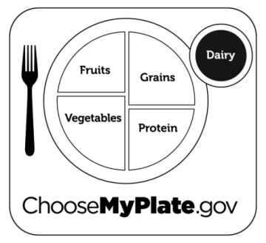
MyPlate, the Aesthetic Guidelines and Knife Skills:
-Use MyPlate as a healthy guide while planning your meal. You should include all 5 food groups.
-Use as many Aesthetics as possible: Color, Texture, Flavor, Temperature, Size & Shape.
-Also, you will need to use at least 3 of the knife cuts we learned in class: Julienne, Brunoise, Small Dice, Medium Dice, Chiffonade, Diagonal & Mince.

Menu:
Main Course:_______________________________________________________________
Dessert:____________________________________________________________________

Grading Rubric: Grade yourself! Look at the criteria below and give yourself the points you earned.
Criteria | Points Possible | Points Earned
Menu uses a variety of aesthetics.  (colors, textures, flavors, temperatures, sizes and shapes) | 10
Menu includes all 5 food groups of MyPlate.  (fruits, vegetables, grains, protein, dairy) | 10
Menu includes a main course made from scratch. | 10
Menu includes a dessert made from scratch. | 10
Meal includes at least 3 specific Knife Skills learned in class: (Julienne, Brunoise, Small Dice, Medium Dice, Chiffonade, Diagonal, Mince) | 10
Picture of meal presented with this form upon completion.  (show teacher a picture on your phone or email picture to: or jenn.russell@washk12.org) | 5
Evaluation completed (on the back of this paper). | 10
Meal completed by the given due date. | 5
Total Points Possible: 70 /70

Meal Evaluation

- Identify the colors, textures, flavors, temperatures, sizes and shapes you used in your meal.

- Menu includes all 5 food groups of MyPlate. Identify each food from your menu and write it in its proper food group(s) below:
Food Group | Menu Items
Fruits
Vegetables
Protein
Grains
Dairy

- Meal includes at least 3 specific knife cuts. Identify each knife cut used and list the food item that you cut in that style:
Knife Cut | Menu Items
1.
2.
3.

- Time Management principles were used:
  - Assembled all ingredients before beginning. Not at all—1 2 3 4 5—Amazing!
  - Worked on several items at the same time. Not at all—1 2 3 4 5—Amazing!
  - Cleaned up as you went along. Not at all—1 2 3 4 5—Amazing!

- Meal presentation looked appealing and tasted good. Not at all—1 2 3 4 5—Amazing!

- Table was set properly. Not at all—1 2 3 4 5—Amazing!

- Completed clean up at the end of the meal. Not at all—1 2 3 4 5—Amazing!
PARENTS/GUARDIANS: Please comment below concerning the satisfactory completion of this assignment.

Parent/Guardian Signature_________________________________ Student Signature____________________________________

